Student Attendance System
Version 1.1

Student Attendance System | Version: 1.1
System Specification | Date: 09/01/2025

Document Change Log
Date | Version | Description | Author
09/01/2025 | 1.1 | Student attendance system | Group 11

I. Functional Requirements
Main functional requirements for the student attendance system:
- User Login and Authentication: The system allows users (teachers, students, administrators) to log in with their account credentials. After login, the system authenticates their role to grant appropriate access permissions.
- Student Information Management: Administrators can add, edit, and delete student information (including student ID, name, class, gender, email). Teachers can view the list of students in their assigned classes.
- Student Attendance: Teachers can perform daily attendance for classes, marking students as present or absent (with or without permission). The system automatically records the attendance time.
- View and Report Attendance:
  - Students can view their personal attendance history.
  - Teachers can view attendance reports for classes (by day, week, month).
  - Administrators can export consolidated reports for the entire school, including absence rates.
- Update and Edit Attendance: Teachers can edit attendance if there are errors (e.g., late student arrival), with notes providing reasons.
- Class and Schedule Management: Administrators can create and edit classes and assign responsible teachers. The system supports scheduling to remind about attendance.
- Logout: Users can safely log out of the system.

II. Non-functional Requirements

Constraint language: Python
Quality attributes of the system, not directly related to specific functions:
- Performance: The system must process attendance for at least 100 students/class within 5 seconds. Report loading time should not exceed 10 seconds.
- Security: User data must be encrypted (e.g., hashed passwords). Only authorized users can access sensitive data. The system must protect against basic attacks such as SQL injection.
- Availability: The system must operate 99% of the time, with daily data backup mechanisms.
- Usability: The interface must be simple and easy to use for non-technical users (teachers and students). Support Vietnamese language.
- Scalability: The system can be expanded to support additional schools or integrate with other systems (such as tuition management systems).
- Compatibility: The system runs on Windows, Linux, and macOS platforms. If it has a web interface, it supports popular browsers like Chrome and Firefox.
- Reliability: The system must handle errors gracefully, for example: displaying error messages instead of crashing.

III. Data Flow Diagram

1. DFD Level 0

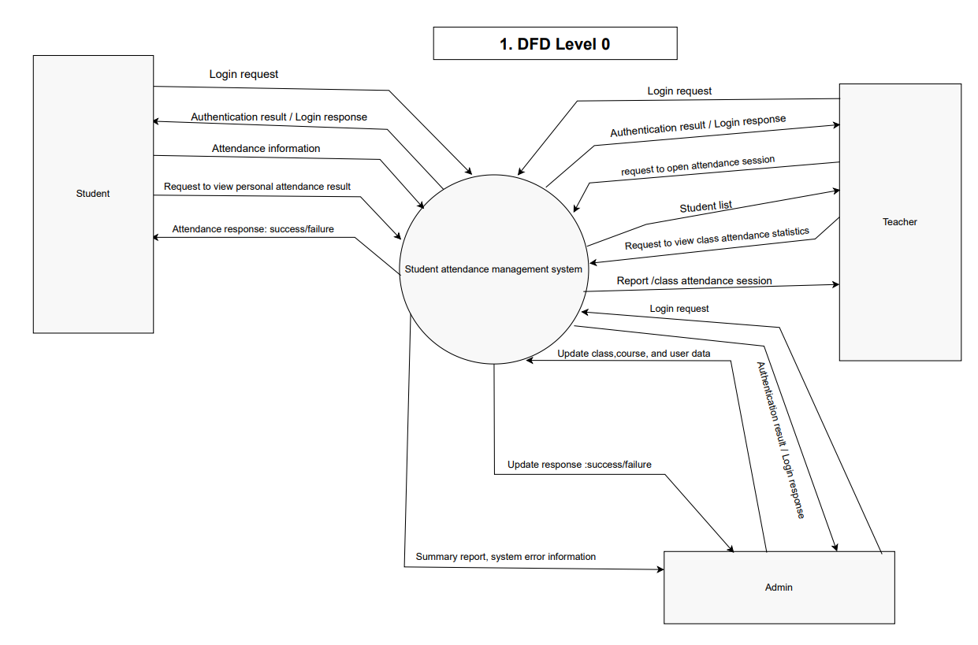

1.1. Overview
- DFD Level 0 diagram describes the overall information flow between the Student Attendance Management System and three main external actors: Student, Teacher, and Admin.
- The system acts as a central processor, receiving requests, processing attendance data, and returning results or reports to each type of user.

1.2. External Actors
Student
- Sends login request to the system.
- Receives authentication response (successful or failed login).
- Sends attendance information when participating in class sessions (e.g., scanning QR code or entering session code).
- Sends request to view personal attendance history (total sessions present/absent, attendance percentage, etc.).
- Receives attendance confirmation result and detailed response information from the system.
Teacher
- Sends login request to access the system.
- Receives authentication response.
- Sends request to open new attendance session (for specific class or subject).
- Receives list of students in the class for attendance marking.
- Sends class attendance report after each session.
- Sends request to view class attendance statistics and receives consolidated report from the system.
Admin (Administrator)
- Sends login request with administrative credentials.
- Updates system data such as user accounts, classes, and subjects.
- Receives update response (success or failure).
- Sends request to view consolidated system reports (attendance statistics, logs, errors).
- Receives consolidated reports and system status feedback.

1.3. Main System Functions
The system performs the following main functions:
- User Authentication: Authenticates login information and manages access rights (Student, Teacher, Admin).
- Attendance Data Management: Records, updates, and retrieves attendance data for each session.
- Class and User Data Management: Allows Admin to update user information, classes, and subjects.
- Reporting and Statistics: Generates reports and statistics for teachers and administrators.
- Feedback and Communication: Provides feedback for login, attendance, and data update operations.

1.4. Main Data Flows
Data Flow | Source | Destination | Description
Login Request | Student/Teacher/Admin | System | Login information sent for verification.
Authentication Response | System | Student/Teacher/Admin | Authentication result (success/failure).
Attendance Information | Student | System | Attendance data sent from student.
Attendance Result | System | Student | Attendance result feedback.
Open Attendance Session | Teacher | System | Request to open new attendance session.
Class Attendance Report | System | Teacher | Class attendance statistics.
Data Flow | Source | Destination | Description

2. DFD Level 1

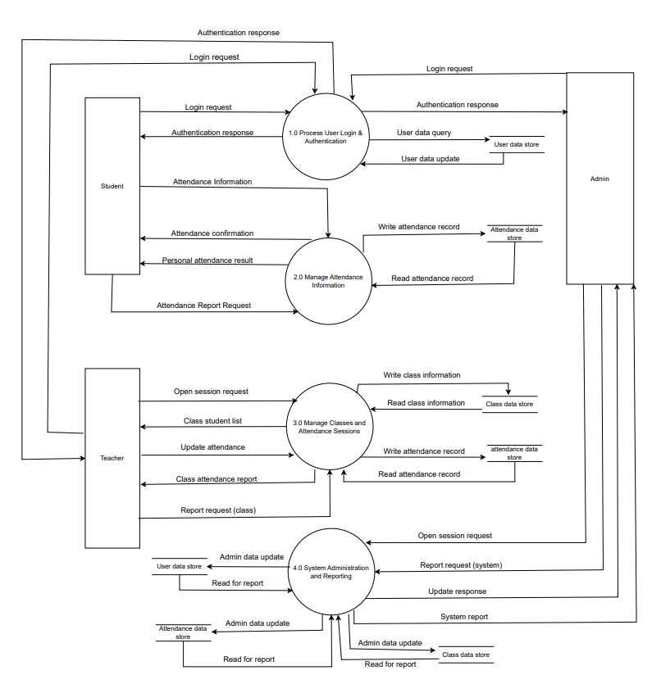

2.1. Overview
DFD Level 1 decomposes the main system into four internal Processes, describing how data is processed, stored, and exchanged between internal components and external actors.

Process 1.0 -- Process User Login & Authentication
Function Description:
- Processes login requests from Student, Teacher, and Admin.
- Checks user information in User Data Store.
- Sends authentication response (success/failure) and assigns user role.
Data Flow:
- Input: Login Request
- Output: Authentication Response
- Data Store: User Data Store
Purpose: Ensures only valid users can access the system.

Process 2.0 -- Manage Attendance Information
Function Description:
- Receives attendance data sent by students or teachers.
- Stores attendance data in Attendance Data Store.
- Allows students to view personal attendance history.
- Creates class attendance reports for teachers.
Data Flow:
- Input: Attendance Information, Attendance Report Request
- Output: Attendance Confirmation, Personal Attendance Result, Class Report
- Data Store: Attendance Data Store
Purpose: Manages recording, retrieval, and validation of attendance data.

Process 3.0 -- Manage Classes and Attendance Sessions
Function Description:
- Manages class, subject, and attendance session information.
- Allows teachers to open or close attendance sessions.
- Updates student lists and attendance results.
- Generates consolidated class attendance reports.
Data Flow:
- Input: Open Session Request, Update Attendance
- Output: Class Student List, Attendance Report (Class)
- Data Store: Class Data Store, Attendance Data Store
Purpose: Supports teachers in organizing and managing attendance activities.

Process 4.0 -- System Administration and Reporting
Function Description:
- Allows Admin to maintain and update system data (users, classes, subjects).
- Consolidates attendance and class data to create system-wide reports.
- Monitors system operations and performance.
Data Flow:
- Input: Admin Data Update, Report Request (System)
- Output: Update Response, System Report
- Data Store: User Data Store, Class Data Store, Attendance Data Store
Purpose: Ensures consistency, accuracy, and currency of system data.

2.2. Data Stores
Data Store | Purpose | Stored Data
User Data Store | Manage user accounts | Username, password, role (Admin, Teacher, Student)
Class Data Store | Manage class information | Class name, subject, student list
Attendance Data Store | Record attendance sessions | Attendance status, date/time of session, student information

2.3. Relationships Between Processes
- Process 1.0 is the system entry point, performing user authentication.
- After authentication, users interact with Process 2.0 and Process 3.0 to perform attendance and class management tasks.
- Process 4.0 integrates data from all Processes to create reports and support system administration.

IV. Use Case Diagram

1. Overview Diagram
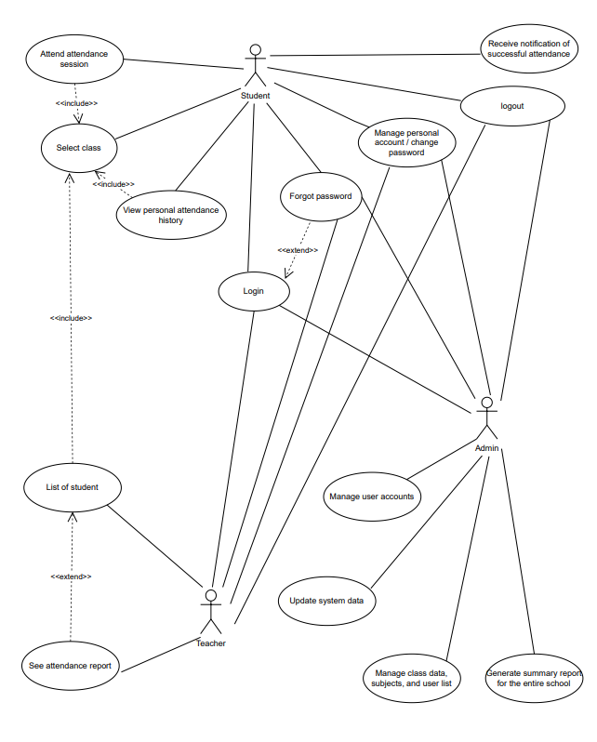

2. Actor List
No. | Actor | Description
1 | Student | Student enrolled in class, can attend, confirm, and view personal attendance history.
2 | Teacher | Instructor managing classes, opening/closing attendance sessions and viewing attendance reports.
3 | Admin | Administrator managing accounts, classes, subjects and monitoring system activities.

3. Use Case List
No. | Use Case Name | Related Actors
1 | Login | Admin, Teacher, Student
2 | Logout | Admin, Teacher, Student
3 | Forgot Password | Admin, Teacher, Student
4 | Manage User Accounts | Admin
5 | Manage Class Data, Subjects, and User List | Admin
6 | Update System Data | Admin
7 | See Attendance Report | Teacher
8 | Select Class | Teacher, Student
9 | View Personal Attendance History | Student
10 | Receive Notification of Successful Attendance | Student
11 | Manage Personal Account / Change Password | Admin, Teacher, Student
12 | View List of Students | Teacher
13 | Confirm Attendance Record | Teacher
14 | Edit Attendance Results | Teacher
15 | Generate summary report for the entire school | Admin

4. Use Case Descriptions

4.1. Use Case: Login
Summary:
This use case allows the user (Admin, Teacher, or Student) to access the system by entering valid login credentials.
Main Flow:
- The user selects the “Login” function.
- The system displays the login interface that requires a username and password.
- The user enters the login information and selects “Login.”
- The system verifies the provided credentials.
- If valid → access is granted.
- If invalid → an error message is displayed.
Alternative Flow:
- If the user forgets their password, they can proceed to the Forgot Password use case.
Special Requirements:
None.
Precondition:
The user has a registered account in the system and is currently logged out.
Postcondition:
If successful, the user gains access to their respective dashboard (Admin, Teacher, or Student).
Extension Point:
Forgot Password.

4.2. Use Case: Logout
Summary:
This use case allows the user to safely exit the system and terminate their active session.
Main Flow:
- The user selects the “Logout” option.
- The system displays a confirmation dialog box.
- The user confirms the action.
- The system ends the session and returns the user to the login screen.
Precondition:
The user is currently logged into the system.
Postcondition:
The user is logged out, and all session data are cleared.

4.3. Use Case: Forgot Password
Summary:
This use case allows a user to recover their account password when forgotten.
Main Flow:
- The user selects “Forgot Password.”
- The system requests the user’s registered email or phone number.
- The user provides the information and submits the request.
- The system verifies the information:
- If valid → a password reset link or a new password is sent to the user’s email.
- If invalid → an error message is displayed.
Special Requirements:
The new password must be automatically generated and securely encrypted before storage.
Precondition:
The user is not logged in.
Postcondition:
A new password or reset link is sent to the user.

4.4. Use Case: Manage User Accounts
Summary:
This use case allows the Admin to add, update, or delete user accounts.
Main Flow:
- The Admin selects the “Manage User Accounts” function.
- The system displays a list of existing users.
- The Admin can perform the following actions:
- Add a new account.
- Edit user information.
- Delete a user account.
- The system saves the changes and displays a confirmation message.
Precondition:
The Admin must be logged in.
Postcondition:
The user list in the system is updated.

4.5. Use Case: Manage Class Data, Subjects, and User List
Summary:
This use case allows the Admin to manage class information, subjects, and student lists.
Main Flow:
- The Admin selects “Manage Class Data.”
- The system displays the list of classes and subjects.
- The Admin may:
- Add new classes or subjects.
- Update existing information.
- Delete outdated entries.
- The system saves and confirms the update.
Precondition:
Admin has logged into the system.
Postcondition:
The class, subject, and user list data are updated successfully.

4.6. Use Case: Update System Data
Summary:
This use case allows the Admin to update global system data (e.g., academic year, version, or other configuration parameters).
Main Flow:
- The Admin selects “Update System Data.”
- The system displays a list of available data categories.
- The Admin edits or uploads new data.
- The system saves and confirms the update.
Precondition:
The Admin is logged in.
Postcondition:
System data are successfully updated.

4.7. Use Case: See Attendance Report
Summary:
This use case allows the Teacher to view class attendance statistics.
Main Flow:
- The Teacher selects “See Attendance Report.”
- The system displays a list of attendance sessions and statistics.
- The Teacher may filter the results by date or student.
Precondition:
The Teacher has recorded attendance data for at least one class.
Postcondition:
The report is displayed successfully.

4.8. Use Case: Select Class
Summary:
This use case allows the Teacher (or Student) to select a class for attendance marking or viewing reports.
Main Flow:
- The user selects “Select Class.”
- The system displays a list of assigned classes.
- The user chooses a class to view or manage.
- The system loads the selected class information.
Precondition:
The user (Teacher or Student) must be logged in.
Postcondition:
The class data are loaded and displayed.

4.9. Use Case: View Personal Attendance History
Summary:
This use case allows the Student to view their own attendance history.
Main Flow:
- The Student selects “View Personal Attendance History.”
- The system retrieves the student’s attendance records.
- The history is displayed, including date, class, and attendance status.
Precondition:
The Student is logged in.
Postcondition:
Attendance records are displayed to the Student.

4.10. Use Case: Receive Notification of Successful Attendance
Summary:
This use case allows the Student to receive a notification once their attendance has been successfully recorded.
Main Flow:
- After the Teacher saves attendance data, the system automatically generates a success notification.
- The Student receives the notification within the application.
Precondition:
The Teacher has saved attendance results.
Postcondition:
A confirmation notification is displayed for the Student.

4.11. Use Case: Manage Personal Account / Change Password
Summary:
This use case allows any user to update personal information or change their password.
Main Flow:
- The user selects “Manage Personal Account.”
- The system displays current personal details.
- The user edits personal data or enters a new password.
- The system verifies and saves the updates.
Precondition:
The user is logged in.
Postcondition:
Personal information or password is updated successfully.

4.12. Use Case: View List of Students
Summary:
This use case allows the Teacher to view the list of students assigned to their class.
Main Flow:
- The Teacher selects “View List of Students.”
- The system displays the list of students in the selected class.
- The Teacher can view detailed information for each student.
Precondition:
The Teacher has selected a class.
Postcondition:
The list of students is displayed.

4.13. Use Case: Confirm Attendance Record
Summary:
This use case allows the Teacher to verify and confirm attendance results after marking.
Main Flow:
- The Teacher completes the attendance marking.
- The Teacher selects “Confirm Attendance Record.”
- The system displays the attendance summary.
- The Teacher confirms the data.
- The system locks the attendance record for editing.
Precondition:
Attendance data have been recorded but not yet confirmed.
Postcondition:
Attendance record status changes to “Confirmed.”

4.14. Use Case: Edit Attendance Results
Summary:
This use case allows the Teacher to modify attendance information after identifying an error.
Main Flow:
- The Teacher selects “Edit Attendance Results.”
- The system displays previously saved attendance records.
- The Teacher makes necessary corrections.
- The system saves the updated results and displays a success message.
Precondition:
The Teacher has access to attendance records.
Postcondition:
Attendance data are updated successfully.

4.15. Use Case: Generate School-Wide Summary Report
Summary:
This use case allows an administrator or authorized manager to generate and export a summary report of the entire school’s activities, including student data, teacher information, grades, and other statistical details.

Main Flow:
- The user selects the “Generate School-Wide Summary Report” function.
- The user chooses the required information and confirms the report generation request.
- The system collects data from relevant sources (students, teachers, grades, activities, etc.).
- The system compiles the data and generates the report in the selected format (PDF, Excel, etc.).

Special Requirements:
- The report must be accurate, complete, and properly formatted for clear presentation.
- The system must ensure fast processing even with large data volumes.
- Only users with administrator or equivalent privileges can access this function.
Precondition:
The user is logged in and has permission to access the report generation function.
Postconditin:
The school-wide summary report is successfully generated and ready for download or printing.

V. Summary
- This Use Case model describes the main interactions in the attendance management system, showing how each Actor cooperates with the system to perform tasks:
  - Student: record and confirm attendance.
  - Teacher: manage sessions, classes and view report
  - Admin: maintain system data and oversee all operations.
- The diagram and detailed descriptions help understand functional requirements and user interactions in the system.

V. Class Diagram
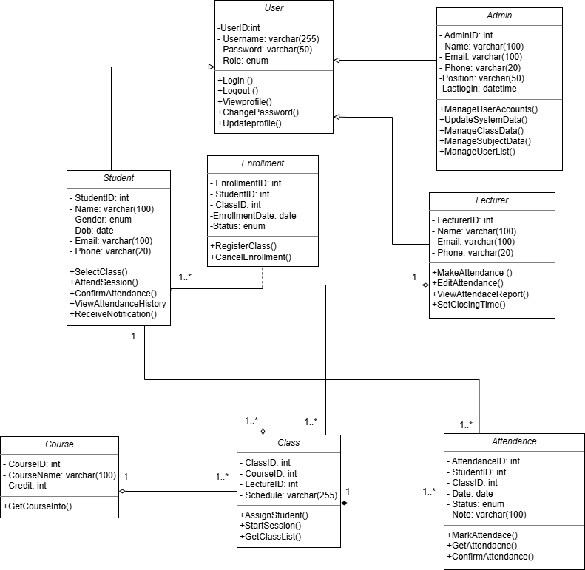

VI. Data Model

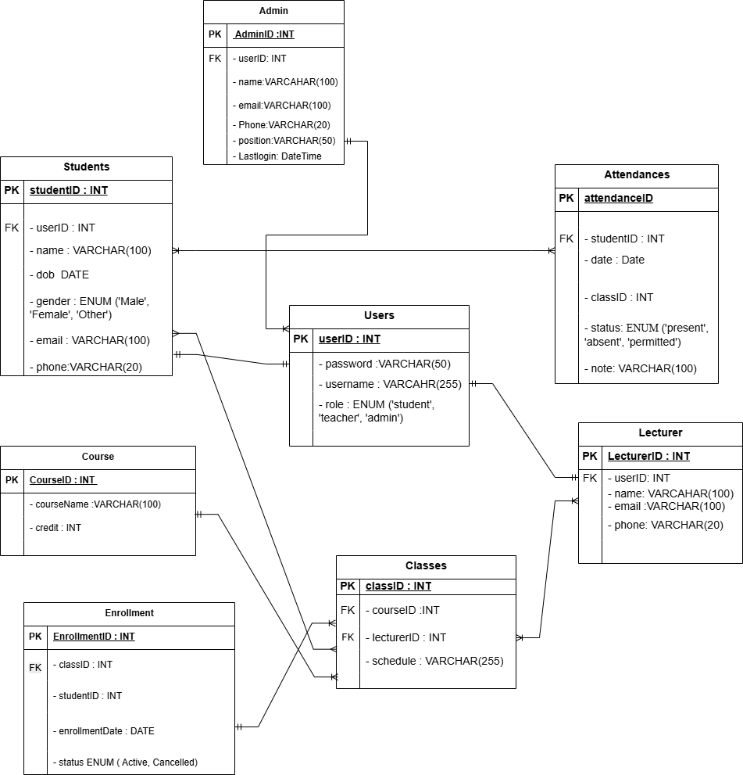

VII. Interface Design Description

1. Login Screen
Purpose: Allow Teacher, Student, and Admin to log into the system.
Layout:
- Title: "Student Attendance System - Login" (large font, dark blue, at top of screen).
- Login form (center of screen):
  - "Username" input field (text box, 200px wide, hint: "Enter ID or email").
  - "Password" input field (password field, 200px wide, dots replacing characters).
  - "Login" button (blue button, 100px x 40px, rounded border, placed on right of form).
- Note: Has "Eye" icon to show/hide password (security: SHA-256 encryption).
- Notification: Small text area below form (red if error: "Incorrect username or password", green if success: "Login successful").
Non-functional Requirements:
- Usability: Vietnamese interface, large buttons easy to click.
- Security: Login data encrypted before sending to server.
- Performance: Process login within 2 seconds for 100 concurrent users.
Redirect: After successful login, navigate to main screen corresponding to role (Teacher Dashboard, Student Dashboard, Admin Dashboard).

2. Teacher Dashboard
Purpose: Display main teacher functions (Attendance, View Reports, Update Attendance).
Layout:
Left Menu Bar (200px wide):
- "Attendance" button (green, selected when active).
- "View Reports" button (gray).
- "Update Attendance" button (gray).
- "Logout" button (red, at bottom).
Main Content Area (remaining screen):
Default (Attendance):
- Title: "Class [Class Name] Attendance" (updates according to selected class).
- Student list table (columns: No., Student ID, Name, Status - "Present"/"Absent" checkbox).
- "Save Attendance" button (blue, 120px x 40px, right of table).
View Reports (when selected from menu):
- Title: "Class Attendance Report".
- Report table (columns: Date, Class Size, Present, Absent, Percentage %).
- "Download PDF" button (blue, on right).
Update Attendance (when selected from menu):
- Title: "Update Attendance".
- Date filter (dropdown: day/month/year).
- List table (columns: No., Student ID, Name, Old Status, New Status - "Present"/"Absent" dropdown).
- "Save Changes" button (blue, on right).
Top Status Bar (50px high): Display "Hello, [Teacher Name]" and real-time (format: "27/10/2025 09:36 PM").
Non-functional Requirements:
- Usability: Responsive interface, suitable for mobile and desktop.
- Performance: Load list of 100 students within 5 seconds.
- Reliability: If network error, display "Check connection" message instead of crash.

3. Student Dashboard
Purpose: Allow students to view their attendance history.
Layout:
Left Menu Bar (150px wide):
- "View Attendance History" button (green, selected when active).
- "Logout" button (red, at bottom).
Main Content Area:
- Title: "Attendance History of [Student Name]".
- History table (columns: Date, Class, Status, Notes - if any).
- "Refresh" button (blue, 100px x 40px, on right).
Top Status Bar (50px high): Display "Hello, [Student Name]" and real-time.
Non-functional Requirements:
- Usability: Large font, easy to read for students.
- Security: Only display current student's data.
- Performance: Load history of 50 records within 3 seconds.

4. Admin Dashboard
Purpose: Allow Admin to manage students, classes, and view consolidated reports.
Layout:
Left Menu Bar (200px wide):
- "Manage Students" button (green, selected when active).
- "Manage Classes" button (gray).
- "Consolidated Reports" button (gray).
- "Logout" button (red, at bottom).
Main Content Area:
Manage Students (default):
- Title: "Student List".
- Table (columns: ID, Name, Class, Gender, Email, Actions - "Edit"/"Delete" buttons).
- "Add Student" button (blue, opens popup form for entering information).
Manage Classes (when selected from menu):
- Title: "Class List".
- Table (columns: Class Code, Class Name, Teacher, Class Size, Actions - "Edit"/"Delete" buttons).
- "Add Class" button (blue, opens popup form).
Consolidated Reports (when selected from menu):
- Title: "Consolidated Report".
- Table (columns: Class, Total Students, Total Present, Total Absent, Average Percentage %).
- "Download Excel" button (blue, on right).
Top Status Bar (50px high): Display "Hello, [Admin Name]" and real-time.
Non-functional Requirements:
- Usability: Popup form has validation (correct email format, required fields).
- Security: Only Admin can access, requires role authentication.
- Performance: Load list of 200 students/classes within 7 seconds.

5. Logout Confirmation Screen
Purpose: Confirm and execute logout.
Layout:
- Title: "Confirm Logout".
- Message: "Are you sure you want to log out? Unsaved data will be lost."
- "Confirm" button (red, 100px x 40px).
- "Cancel" button (gray, 100px x 40px).
Non-functional Requirements:
- Usability: Small popup, center of screen.
- Security: Clear session after logout.
- Reliability: Display error if logout fails.

General Notes
- Language: Interface uses Vietnamese completely, ensuring ease of use for Vietnamese users.
- Theme: Main colors are green (main functions), gray (inactive menu), red (warning/logout), on white background (or dark if dark mode supported).
- Responsive Design: All screens automatically adjust size (mobile: menu collapses to hamburger, desktop: fixed menu).
- Overall Performance: Load entire interface within 5 seconds, handle 100 concurrent users without lag.

